Schedule Split

Step1: open excel and make sure two sheets are present Sheet1 and Sheet 2

Step 2: Copy the schedule from Email , click Sheet1 “A1” Cells and apply Paste Special

Step 3: Open VBA editor by Pressing Alt + F11 and run the module which has

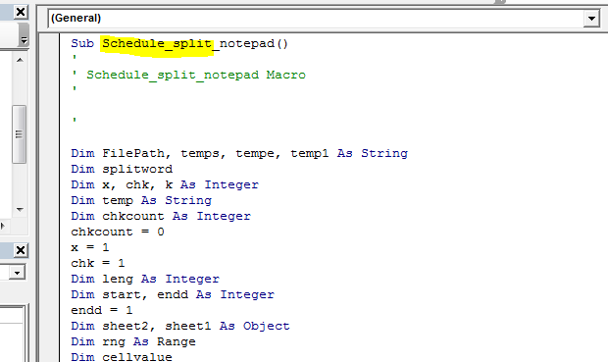

Click run and get notepad result